**WanderingMe**

Angela Hannah Aguirre and Dahlia Tudtud

BS Computer Science 3

University of San Carlos

Table of Contents

Table of Contents............................................................................................................................................................................................ 1

Table of Figures............................................................................................................................................................................................... 2

What is WanderingMe?..................................................................................................................................................................................3

I. Login.............................................................................................................................................................................................................4

II. Registration..................................................................................................................................................................................................5

III. Home.......................................................................................................................................................................................................... 6

IV. Navigation bar.....................................................................................................................................................................................................................7

V. User’s Profile................................................................................................................................................................................................................8

VI. Camera........................................................................................................................................................................................................ 9

VII. About........................................................................................................................................................................................................10

VIII. Settings....................................................................................................................................................................................................11

IX. My Places..................................................................................................................................................................................................12

X. My Friends.................................................................................................................................................................................................13

XI. My Photos................................................................................................................................................................................................ 14

XII. My Events............................................................................................................................................................................................... 15

XIII. Help Center………………………………………………………………………………………………………………………………………… 16

XIV. About Us…………………………………………………………………………………………………………………………………………… 17

XV. Termsof Usage……………………………………………………………………………………………………………………………………… 18

XVI. Support……………………………………………………………………………………………………………………………………………… 19

XVII. Report……………………………………………………………………………………………………………………………………………… 20

WanderingMe Manual Page 1

Table of Figures

I. Login Screen.................................................................................................................................................................................................................4

II. Registration................................................................................................................................................................................................... 5

III. Splash Screen.............................................................................................................................................................................................................. 6

IV. Navigation bar..................................................................................................................................................................................................................... 7

V. User’s Profile................................................................................................................................................................................................................ 8

VI. Camera........................................................................................................................................................................................................ 9

VII. About........................................................................................................................................................................................................ 10

VIII. Settings.................................................................................................................................................................................................... 11

IX. My Places.................................................................................................................................................................................................. 12

X. My Friends................................................................................................................................................................................................. 13

XI. My Photos................................................................................................................................................................................................ 14

XII. My Events............................................................................................................................................................................................... 15

XIII. Help Center………………………………………………………………………………………………………………………………………… 16

XIV. About Us…………………………………………………………………………………………………………………………………………… 17

XV. Termsof Usage……………………………………………………………………………………………………………………………………… 18

XVI. Support……………………………………………………………………………………………………………………………………………… 19

XVII. Report……………………………………………………………………………………………………………………………………………… 20

WanderingMe Manual Page 2

What is WanderingMe ?

WanderingMe is a mobile application that can serve as a guide and organizer for tourists and photographers, who loves to travel and take pictures. It is also an application where it enables the users to recommend hot tourists spots or destinations and also to invite photography enthusiasts to hot events, also it can help business establishments that centralizes on tourists.

WanderingMe Manual Page 3

1. WanderingMe Login

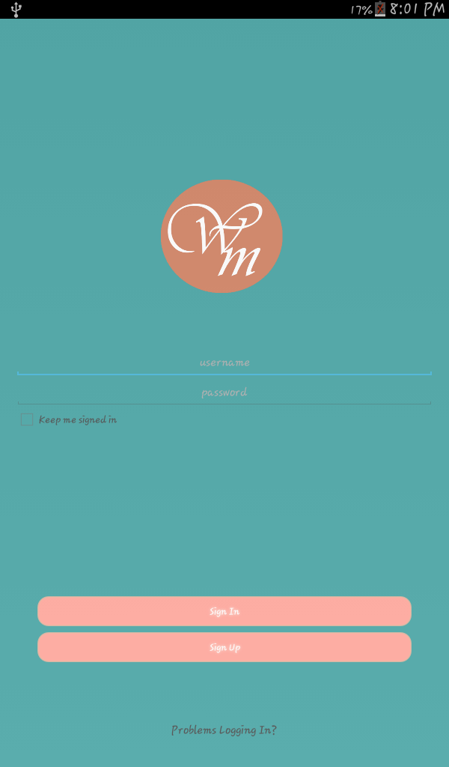

Figure 1.0 shows the login page with containing a text view for the title, text fields for username and password, a check box, buttons for sign up, sign in and help for problems in logging in.

When WanderingMe is launched, the User is presented with a Login Screen. The User can see a username and password text field, login and signup button; keep me login check box and problem logging in link. In order for the User to enter the application he/she should enter his/her username and password and hit login button. If User is not yet registered he/she can hit sign up button to register. If user encounters problems while logging in, he/she can tap problem logging button.

Figure 1.0 Login screen

WanderingMe Manual Page 4

1. WanderingMe Registration

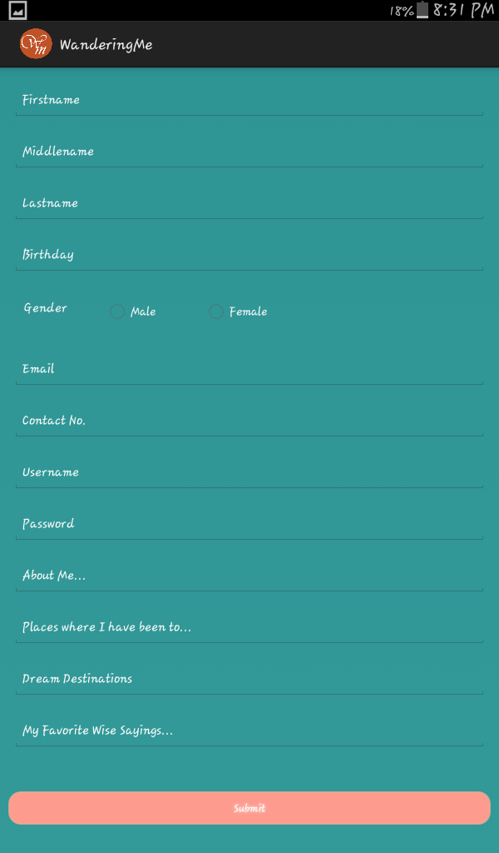

Figure 2.0 shows the Registration Screen with the Following text fields and a submit button.

When Register button from Login Screen and sign in button in Login screen is tapped, the user is then presented with a Register Screen. It contains text fields for Fist name, Last name, Email, Username, Password, Contact No. and Address. All this fields should be filled up by the user and submitted afterwards

Figure 2.0: Registration

WanderingMe Manual Page 5

1. WanderingMe Home



Figure 3.0 shows the Splash Screen containing a welcome and wandering me introduction text field and a next button.

When submit button in Registration screen is clicked the user is then presented with a splash screen. It contains two text views welcoming the user and a simple introduction about the application. There is also a next field for navigation to next screen.

Figure 3.0: Splash Screen

WanderingMe Manual Page 6

1. WanderingMe Navigation Bar

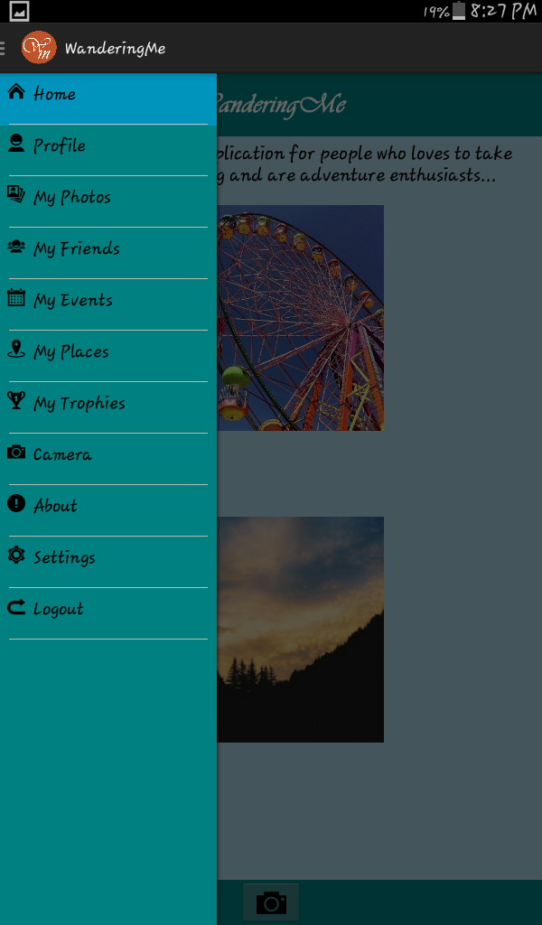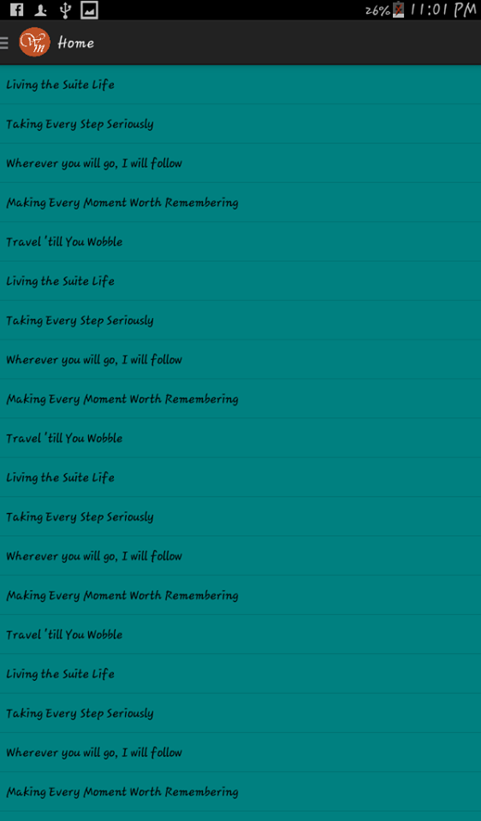

Figure 4.1 shows the Wandering me Screen with a Navigation Drawer, and Figure 4.2 shows Home View Feed.

Upon tapping the next button from Splash Screen, the user is then presented with a wandering me screen with navigation drawer containing the lists of the following items: Home, Profile, My Photos, My Events, My Societies, My Places, My Trophies, Camera, What’s Hot?, About, Settings and Logout. When clicking an item when item within the drawer, the User will be directed into that chosen item.

Figure 4.1: Navigation Drawer Figure 4.2: Home View Feed

WanderingMe Manual Page 7

1. WanderingMe User’s Profile

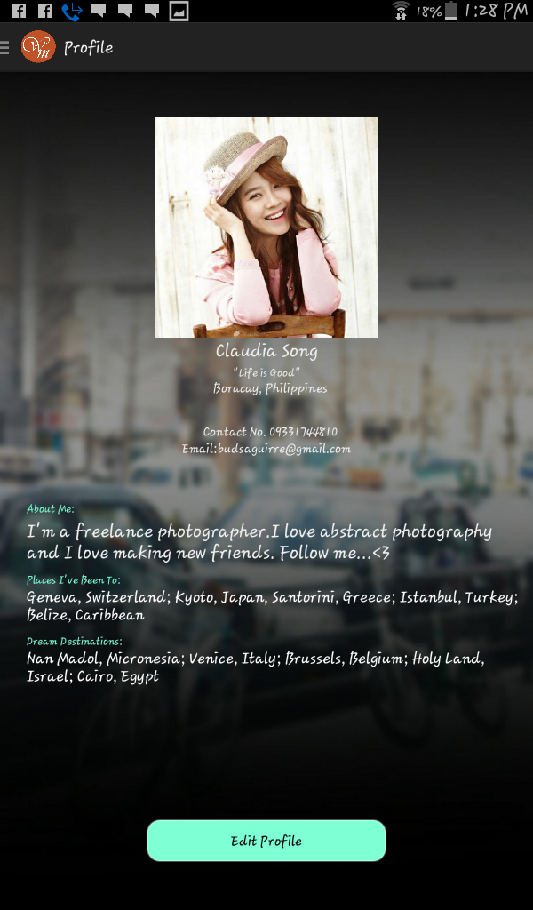

Upon tapping the Profile item from the Navigation Drawer, the user is then presented with a Profile Screen. This screen displays information about the user and its profile picture

Figure 5.0 shows the Profile Screen. It has an image view containing the profile picture of the user. It also had a text fields that contains the following user information: user profile name, address, status, and a short description about her/him.

Figure 5.0: Profile

WanderingMe Manual Page 8

WanderingMe Manual Page 8

1. WanderingMe Camera



Figure 5.0 shows the camera screen with the camera icon, its settings, an image view and video view containing the pictures and videos taken by the user.

When Camera item in Navigation Drawer is tapped the User will be presented with a Camera Screen. In this screen, the user has an option of whether to take picture or a video. The user can also adjust the camera settings.

Figure 6.0: Camera

WanderingMe Manual Page 9

1. WanderingMe About

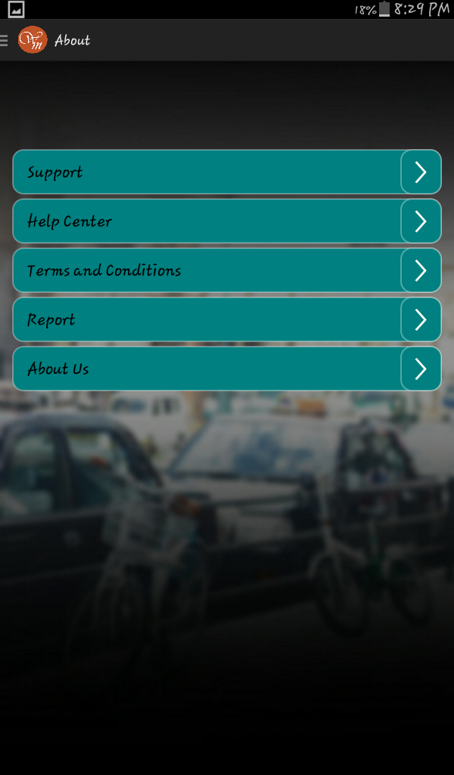

Figure 8.0 shows the About Us page that contains a list of text views and next buttons.

When About item from Navigation Drawer is tapped the user will be directed into About page. This page contains list of following items: About Us, Report, Terms and Conditions, Help Centre and Support.

Figure 8.0: About

WanderingMe Manual Page 10

1. WanderingMe Settings

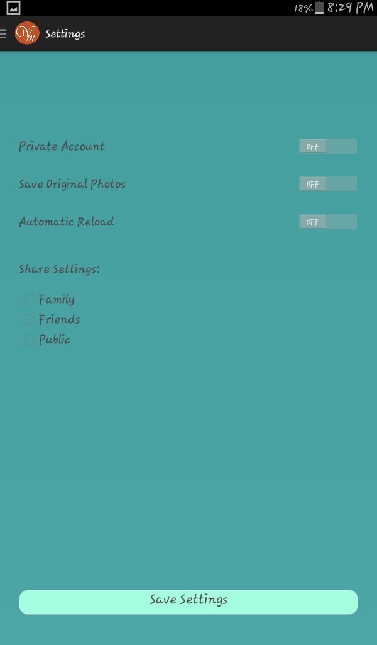

When Settings item from Navigation Drawer is tapped by the user he/she will be directed into the Settings page. In this page the user can adjust the followings settings: Account settings, Account privacy, Reload Settings and Save Original Photo Settings.

Figure 9.0 shows the Settings page. It contains text views for Private Account, Save Original Photos, Automatic Reload and Account Settings. It also had on and off switches, radio buttons and a button for Account Settings.

Figure 9.0: Settings

WanderingMe Manual Page 11

1. WanderingMe My Places

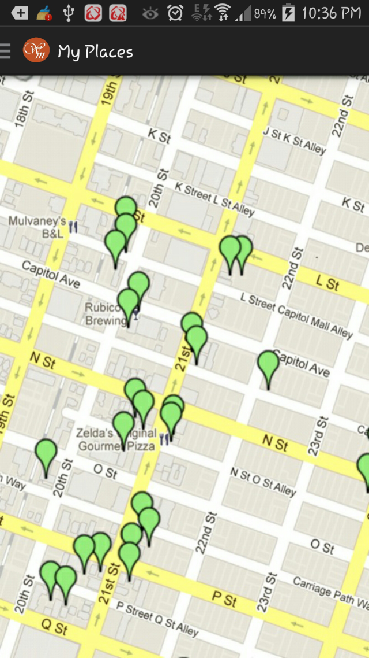

Figure 10.0 shows the My Places page that has a map view.

When My Places item from Navigation Drawer is tapped by the user, he/she will be directed into My Places page. This page displays the map pinning the places where the users have gone to.

Figure 10.0: My Places

WanderingMe Manual Page 12

1. WanderingMe My Friends

When My Friends item from Navigation Drawer is tapped by the user, he/she will be directed into a screen containing a list view of People. This screen is scrollable and each item is clickable.

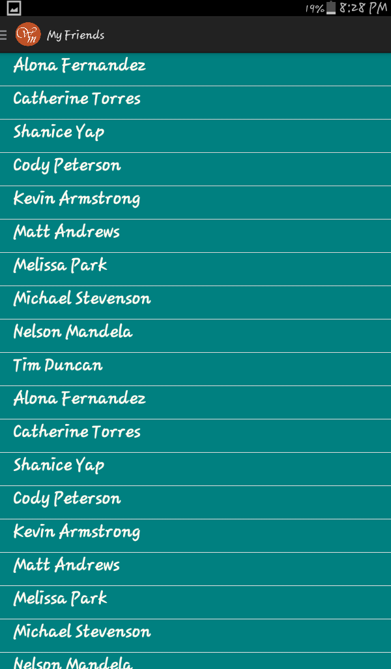

Figure 11.0 shows the user’s friends list View page where it contains an image view of members, text view containing its username and another text view displaying the user’s status.

Figure 11.0 My Friends List View

WanderingMe Manual Page 13

1. WanderingMe My Photos

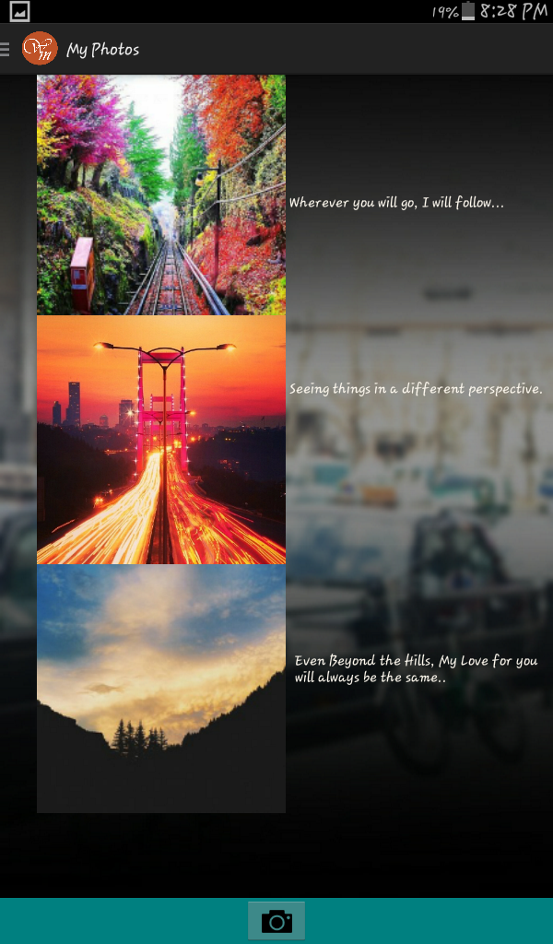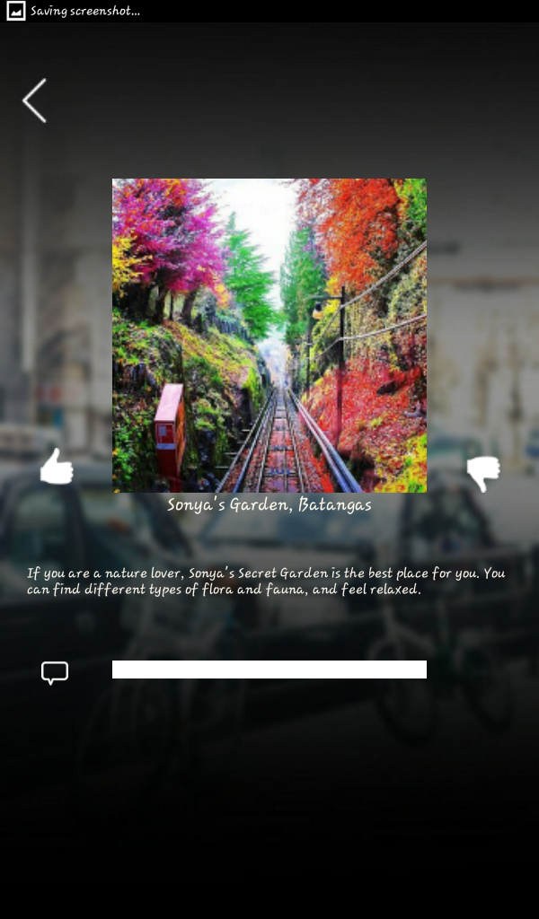

Figure 12.1 shows a My Photos List View that has an image view that displays the pictures of users. It also has a text view that displays information about the photo and Figure 12.2 shows the Photo Detail after it has been clicked from the photos page.

When My Photos item in the navigation bar is tapped by the user, he/she will be directed into the My Photos page. This page shows a list view of User’s Photo’s.

Figure 12.1 My Photos View Figure 12.2 Photo Detail

WanderingMe Manual Page 14

1. WanderingMe My Events

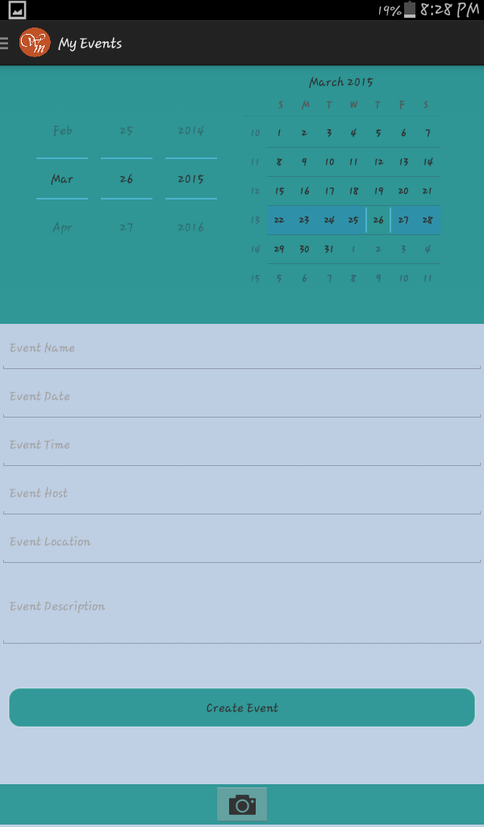

When My Events item from Navigation bar is tapped by user, he/she will be prompted by a calendar, where he/she can tap on a respective date/dates a view the events of those date/dates.

Figure 12.0 shows a calendar with list of events of users.

Figure 13.0 My Events Calendar

WanderingMe Manual Page 15

1. WanderingMe Help Center

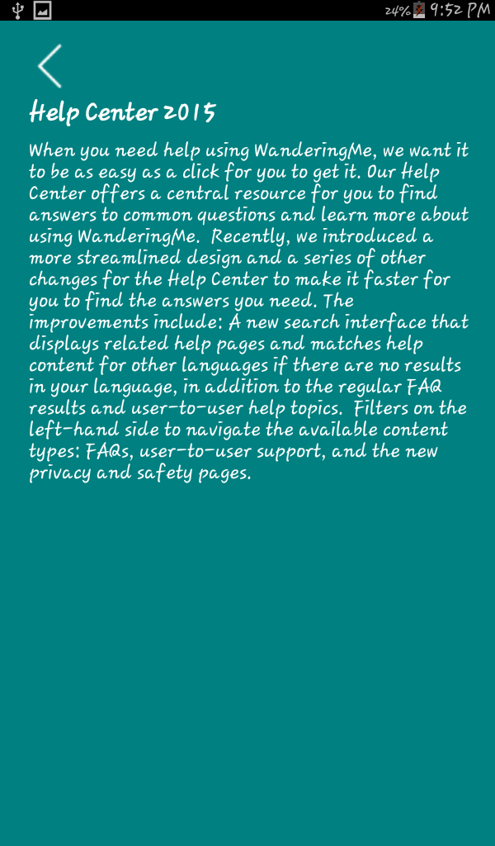

Figure 14.0 shows Help Center containing textviews.

When Help Center button from About Screen is tapped by user he/she will be directed into Help Center Screen.

Figure 14.0 Help Center

WanderingMe Manual Page 16

1. WanderingMe About Us

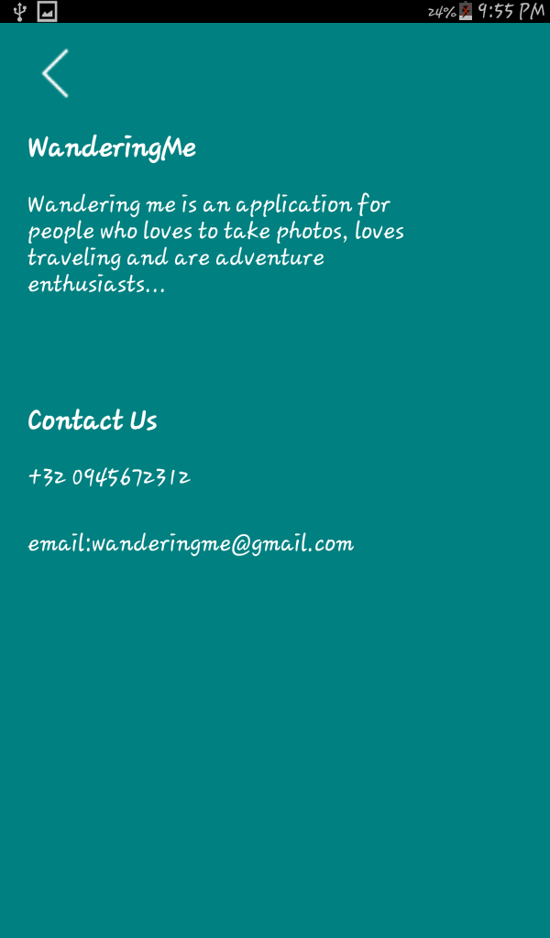

Figure 15.0 shows About Us containing textviews displaying information about the application.

When About Us button from About Screen is tapped by user he/she will be directed into About Us.

Figure 15.0 About Us

WanderingMe Manual Page 17

1. WanderingMe Terms of Usage



Figure 1.60 shows Terms of Usage containing a textview.

When Terms and Conditions button from About Screen is tapped by user he/she will be directed into Terms of Usage Screen.

Figure 16.0 Terms of Usage

WanderingMe Manual Page 18

1. WanderingMe Support

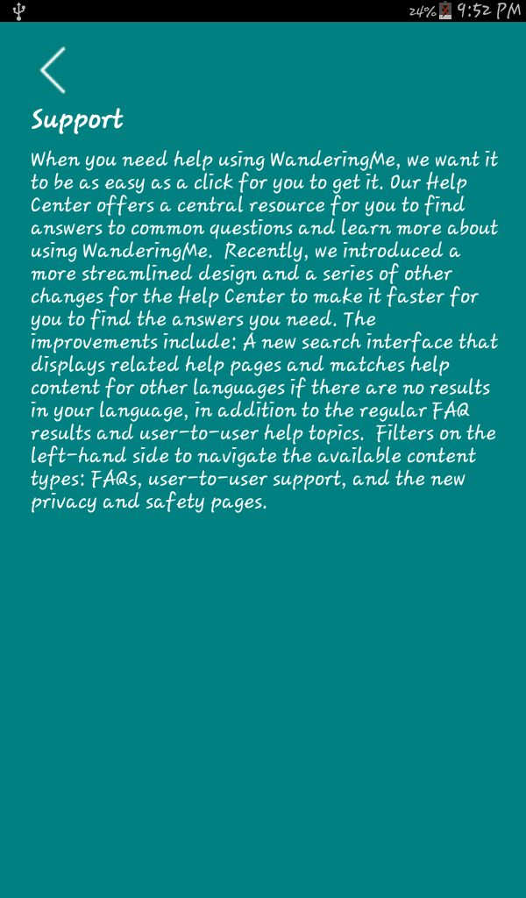

Figure 1.60 shows Support containing a textviews.

When Support button from About Screen is tapped by user he/she will be directed into Support Screen.

Figure 17.0 Support

WanderingMe Manual Page 19

1. WanderingMe Report

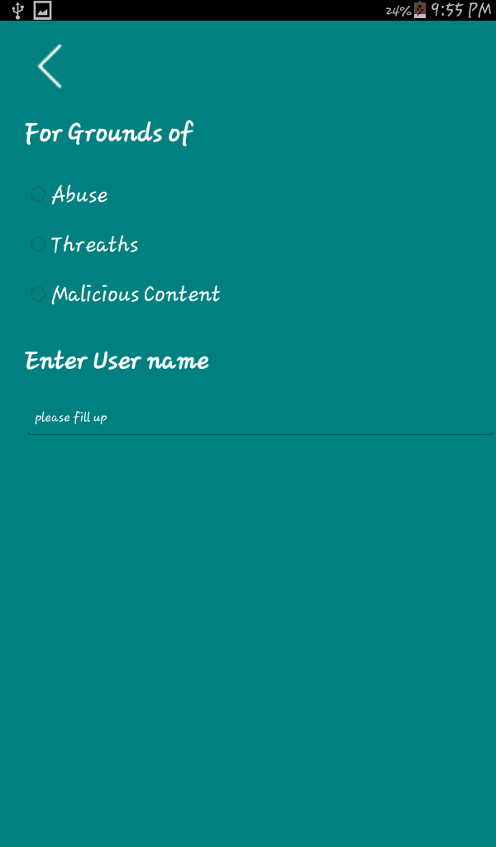

Figure 16.0 shows Report containing a textviews.

When Report button from About Screen is tapped by user he/she will be directed into Report Screen.

Figure 18.0 Report

WanderingMe Manual Page 20

When



Figure 19.0 Photo Detail

WanderingMe Manual Page 21